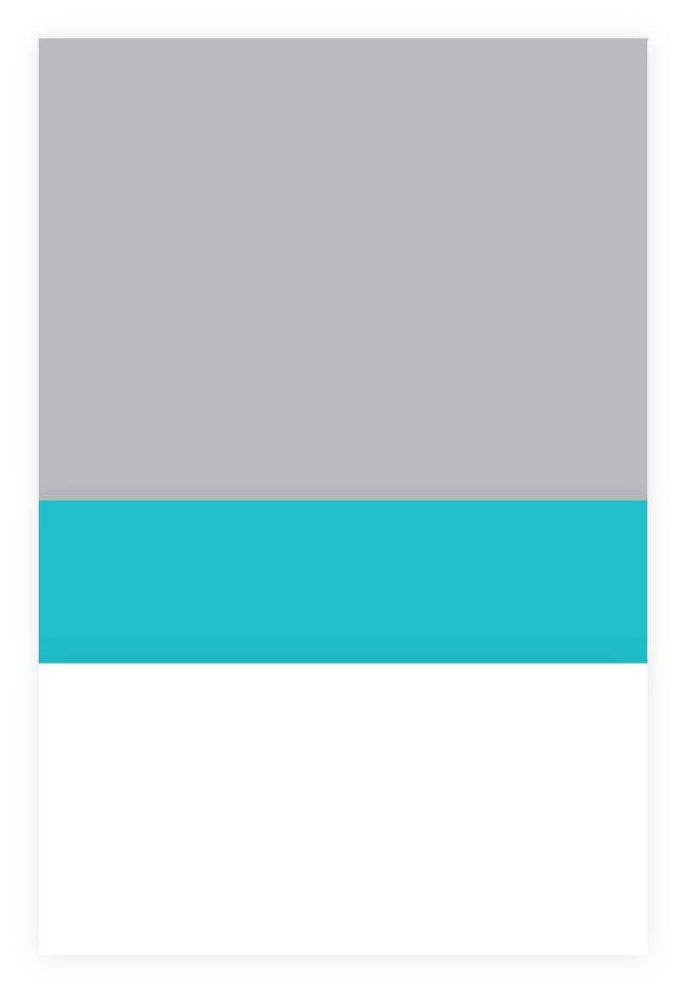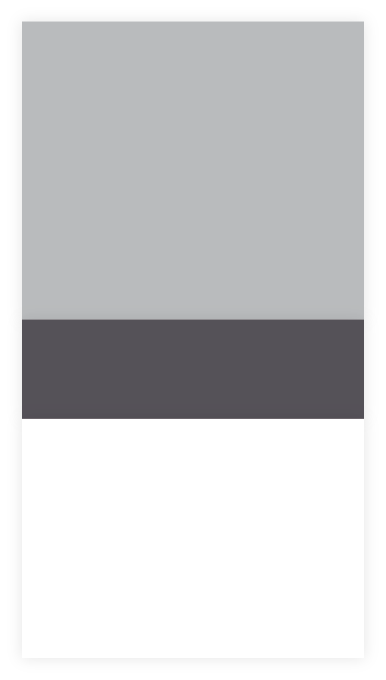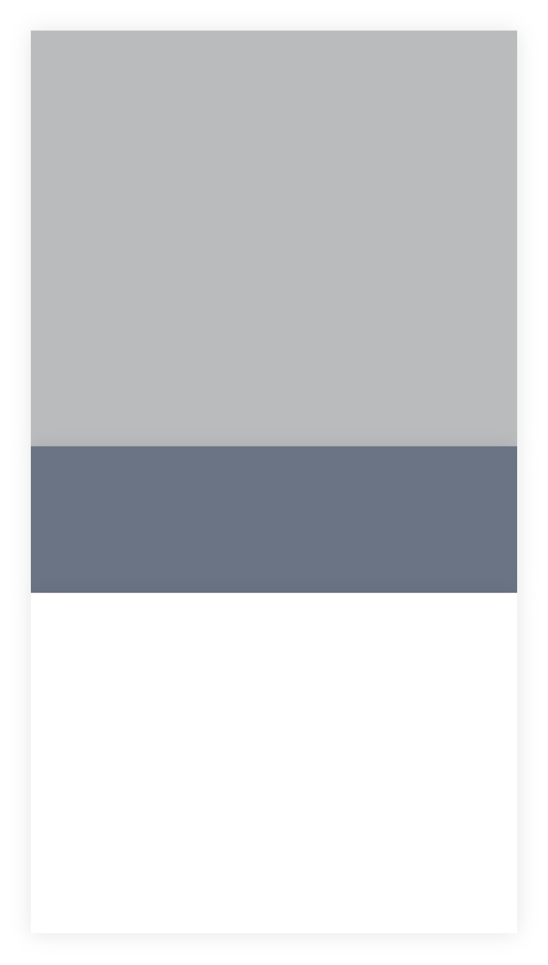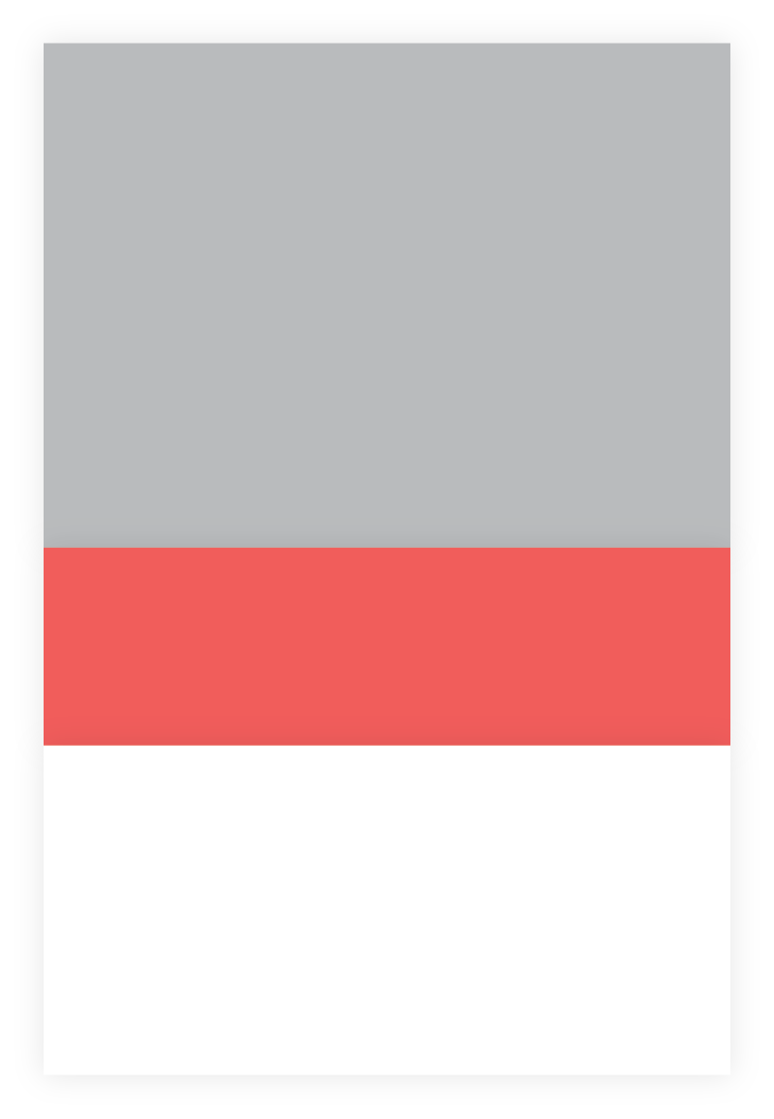

marketing, photography,

Marketing Partner

dribbble.com/rtralrayhan

www.alrayhan.com

Lorem ipsum dolor sit amet, consectetur adipiscing elit, sed do eiusmod tempor incididunt ut labore et dolore magna aliqua.

marketing, photography,

Marketing Partner

Lorem ipsum dolor sit amet, consectetur adipiscing elit, sed do eiusmod tempor incididunt ut labore et dolore magna aliqua.

Lorem ipsum dolor sit amet, consectetur adipiscing elit, sed do eiusmod tempor incididunt ut labore et dolore magna aliqua.

Nullam quised ie risus eget urna mollis ornare vel eurom leope. Praesent commodo cursus magna.

Lorem ipsum dolor sit amet, consectetur adipiscing elit, sed do eiusmod tempor incididunt ut labore et dolore magna aliqua.

Nullam quised ie risus eget urna mollis ornare vel eurom leope. Praesent commodo cursus magna.

branding, ui-ux, article,

Music Player Design

branding, ui-ux, article,

Website Redesign

branding, ui-ux, article,

Website Redesign

Lorem ipsum dolor sit amet, consectetur adipiscing elit, sed do eiusmod tempor incididunt ut labore et dolore magna aliqua.

**Al Rayhan**

Work

Java Script

HTML 5 & CSS 3

Adobe Illustrator

Adobe Photoshop

Professional Skills

SYL-3RF87W

24 Golden Tower (2nd floor)

Amberkhana, Sylhet

Work

ar@deviserweb.com

Personal

mail@alrayhan.com

(880) 1771-299299

Mobile

(880) 1737-662662

Lorem ipsum dolor sit amet, consectetur adipiscing elit, sed do eiusmod tempor incididunt ut labor et dolore magna aliqua. Ut enim ad minim veniamnt in culpa quie officia deserunt mollit.

**UI & UX Expert**